Worksheet 01 – Interface design with different components

We should use the following components to build the App. Finish Task 1 with the following names.
- Screen | - Button | - Label | - Image | - Clock

Task 1 (20 marks): Write down the component names in the boxes below.
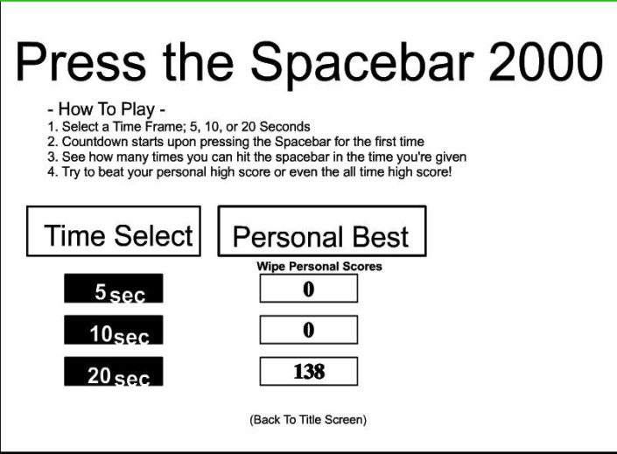
Label
Label
Button
Button
Button
Label
Label
Label

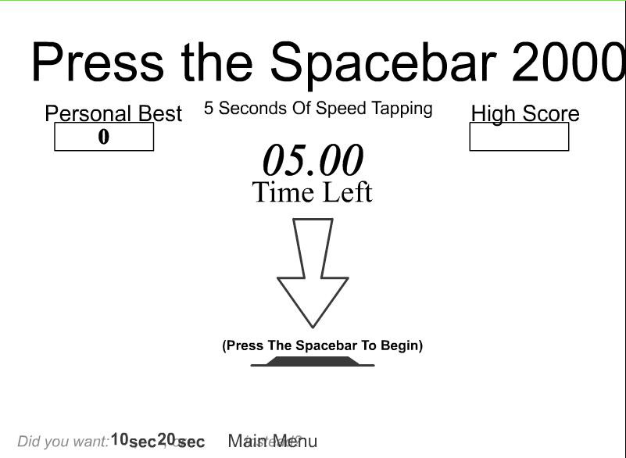
Image
Button

Label
Label
Image
Label

Label

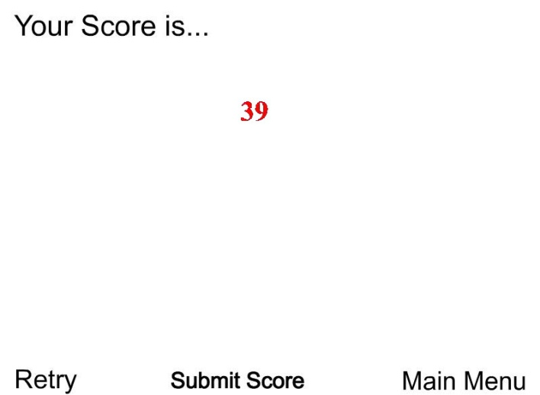
Label
Button

Label
Button

Button

Task 2 (5 marks): Create a project with Youcodia or App Inventor 2 and upload the exported project file (.aia) to the Schoology. ( http://tyo.youcodia.life/ or http://ai2.appinventor.mit.edu/ )

